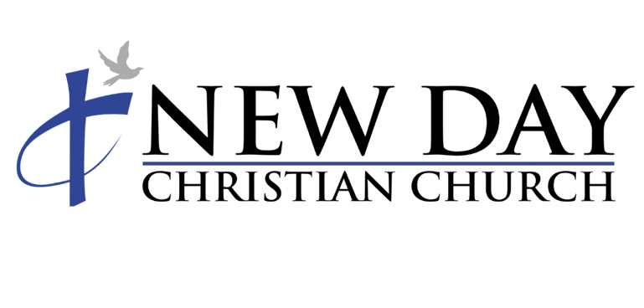

CrossOver Basketball League
2022

Emergency Authorization:
I, the undersigned, hereby authorize the designated coach or church official acting as an activity supervisor, as my agent, to seek medical, surgical, or dental examination and treatment in the event of an injury.
Waiver of Liability and Disclaimer
“My signature below confirms that I have been approved to use the gymnasium facilities at New Day Christian Church. I recognize that this use may involve strenuous physical activity which may include, but is not limited to, muscle strength and endurance training, cardiovascular conditioning and training, and other various sports activities.
I hereby affirm that I am in good physical condition and do not suffer from any known disability or condition which would prevent or limit my participation in such activities. I acknowledge that my use and subsequent participation is purely voluntary and in no way mandated by New Day Christian Church.
In consideration of my participation in this program I, the undersigned, hereby release New Day Christian Church and its agents from any claims, demands, and causes of action as a result of my voluntary participation in activities conducted on New Day Christian Church property.
I fully understand that I may injure MYSELF AS A RESULT OF MY SUBSEQUENT PARTICIPATION IN ACTIVITY PROGRAMS AND I, the undersigned, hereby release New Day Christian Church and its agents from any liability now or in the future for conditions that I may obtain. These conditions may include, but are not limited to, heart attacks, muscle strains, muscle pulls, muscle tears, broken bones, shin splints, injuries to knees, injuries to back, injuries to foot, or any other illness or soreness that I may incur, including death.
Participation includes possible exposure to COVID-19. While particular rules and personal discipline may reduce this risk, I KNOWINGLY AND FREELY ASSUME ALL SUCH RISKS, both known and unknown, and assume full responsibility for my participation; and, I willingly agree to comply with the stated and customary terms and conditions for participation as regards to protection against infectious diseases. If, however, I observe any unusual or significant hazard during my presence or participation, I will remove myself from participation and bring such to the attention of the nearest official immediately.
I agree to allow use of my likeness for program publicity.
I acknowledge that I have read the above information and its contents.”

I HERBY AFFIRM THAT I HAVE READ AND FULLY UNDERSTAND THE ABOVE STATEMENTS.

